

SIMATS ENGINEERING
Saveetha Institute of Medical and Technical Sciences Chennai- 602105

Student Name: K.S.Dharshana Reg.No:192412015
Course Code: CSA1709 Slot: B
Course Name: Artificial intelligence
Course Faculty: Dr.P.Rajaram

Project Title: AI-Based constrain satisfaction solver for automated time table scheduling
Module Photographs:
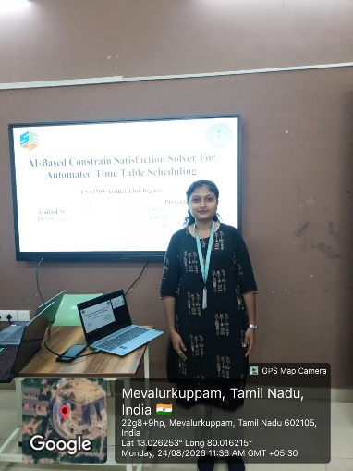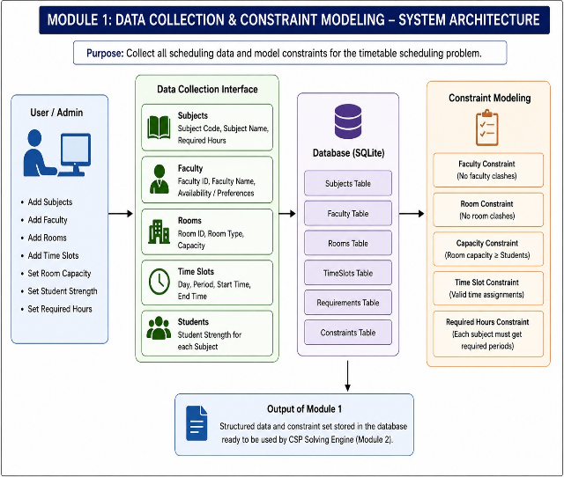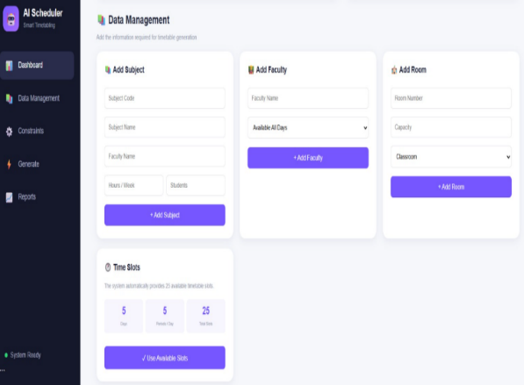

Fig 1.1 Presentation Fig 1.2 System Architecture Fig 1.3 Output
Project Description:
This module is responsible for collecting and organizing all the essential information required for automated timetable scheduling, including subjects, faculty members, classrooms, room capacities, student strength, required subject hours, and available time slots. The collected data is stored in an SQLite database for further processing by the CSP solver. The module also defines the important scheduling constraints, such as faculty conflicts, room conflicts, room capacity, time-slot availability, and required weekly hours. These constraints form the foundation of the Constraint Satisfaction Problem and ensure that the generated timetable is practical, conflict-free, and suitable for the available academic resources.

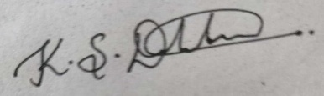
Student Signature Guide Signature

